reg no: 192111496

Name: M KRISHNA VAMSHIDHAR REDDY

**CODE:CSA1366**

**EXPERIMENT: 3**

**AIM:** To design a PDA for the input a^nb^n

**PROCEDURE:**

1. Select three states and consider one as initial and another as final state.
2. Join the states using edges with directioons
3. Select the edges as a or b or c.
4. Start the stimulation and give the input.

**DESIGN AND INPUT:** 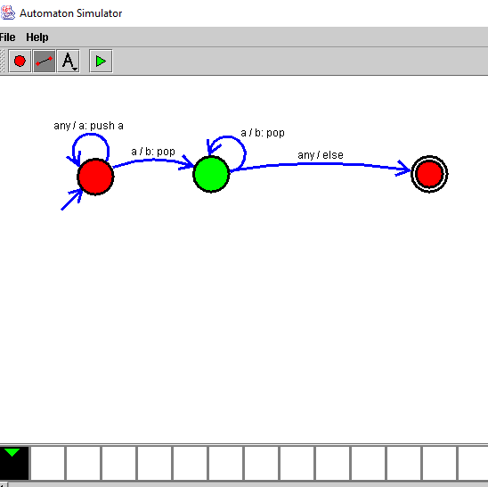

**RESULT:**

Therefore the design of PDA for the given input has been successfully created.